**MODULE 1-4**

**1.** Install VirtualBox or VMware. Set up a virtual machine with any Linux distribution (preferably Kali Linux).

* + **Screenshot Submission:** Screenshot of VirtualBox/VMware with the virtual machine running.

**2.**  Install Kali Linux in your virtual machine and update it..

* + **Screenshot Submission:** Screenshot of the terminal showing the completion of the update.

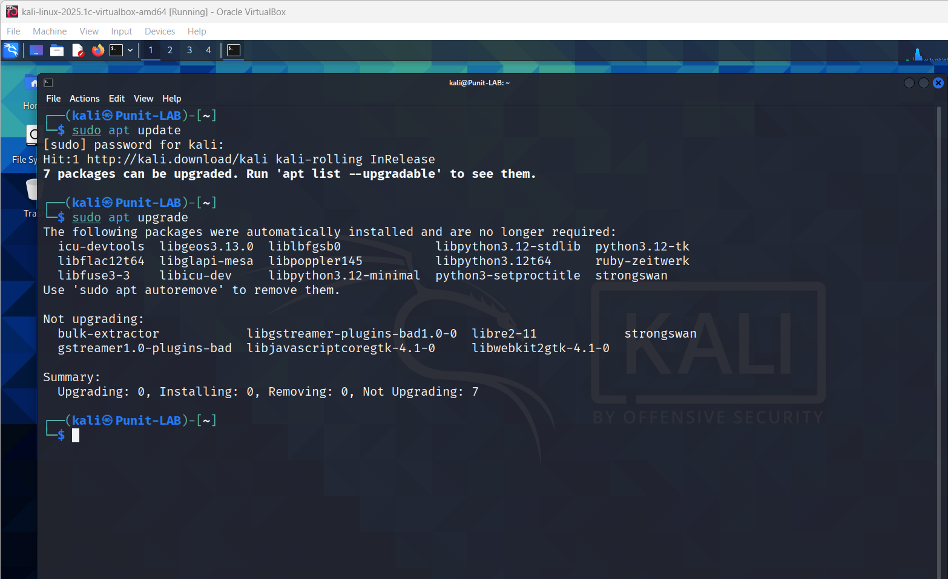

**3.** Explore the applications menu in Kali Linux. List 5 tools and their purpose.

* + **Screenshot Submission:** Screenshot of the applications menu.

**4.** Execute the following Linux commands:

* + Find command
  + Ping command
  + Traceroute command
  + Whoami command
  + Ps command
  + **Screenshot Submission:** Screenshot of terminal output for each command.

